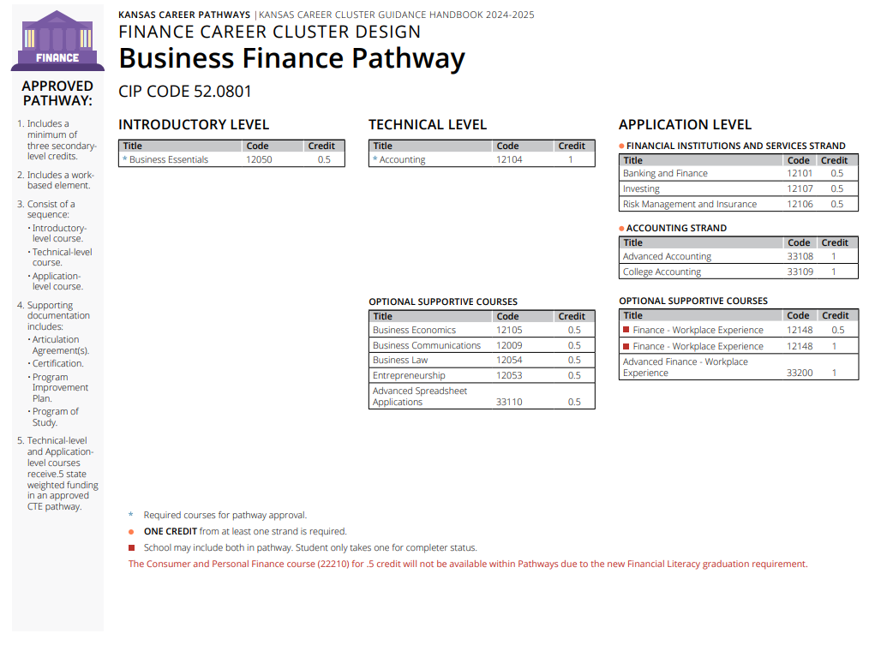
Prior to the Cluster Review
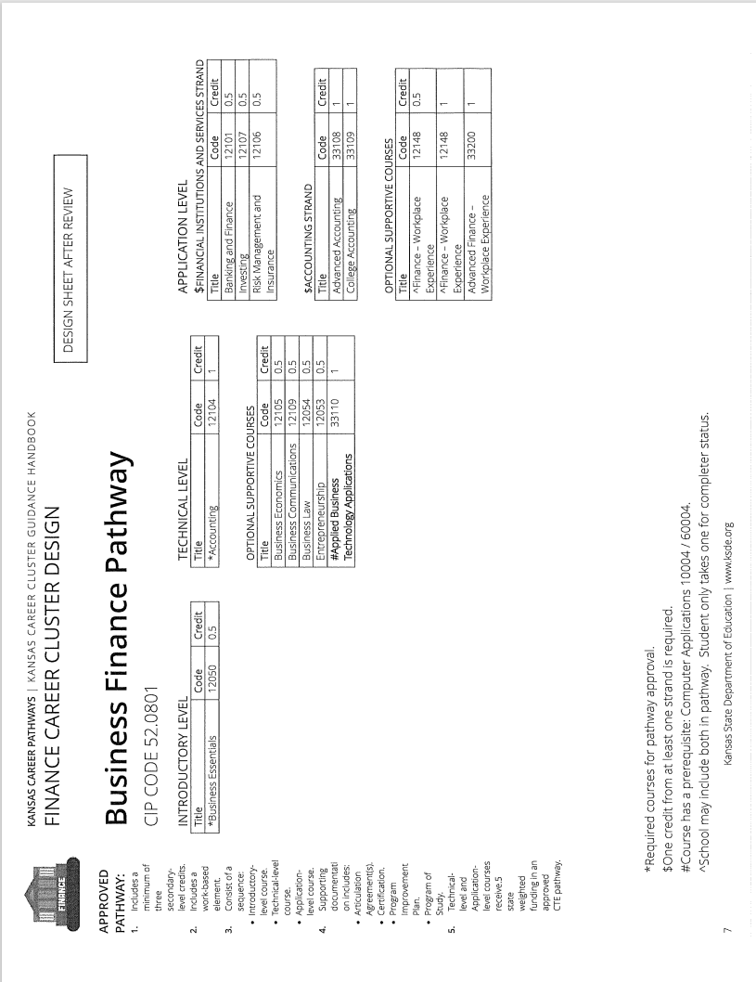
Recommendations Following Cluster Review
Pathway Recommendations Summary:

No Recommend Changes CTE Course Competencies and Indicators (ksde.org)
- Courses not reviewed by this committee.
  - 12009 Business Communications
  - 12050 Business Essentials
  - 12053 Entrepreneurship
  - 12054 Business Law
- Courses with No Changes
  - 12148 Finance – Workplace Experience
  - 33200 Advanced Finance – Workplace Experience

Courses Reviewed with Recommended Changes
- 12104 Accounting – Competencies updated
- 12105 Business Economics – Competencies updated
- 12101 Banking and Finance
- 12107 Investing
- 12106 Risk Management and Insurance
- 33108 Advanced Accountinhg
- 33109 College Accounting
- 33110 Advanced Spreadsheet Applications changed to 33110 Applied Business Technologies
  - Competencies added
  - Changed to 1 credit from .5 credit
  - Competencies align with KBOR Computer Concepts and Applications CSC1010
  - Prerequisite is Computer Applications 100004/60004

